**Overall Report on Car Prices and Sales in Different Cities**

**1. Introduction**

This report analyzes the **average car prices** and **vehicle sales distribution** across multiple Indian cities. The insights are derived from three key visualizations:

1. **Bar Chart of Average Car Prices**
2. **Bar Chart of Vehicle Sales**
3. **Pie Chart of Vehicle Sales Distribution**

The goal is to identify trends, correlations, and potential market opportunities in the automotive sector.

**2. Average Car Prices in Different Cities**

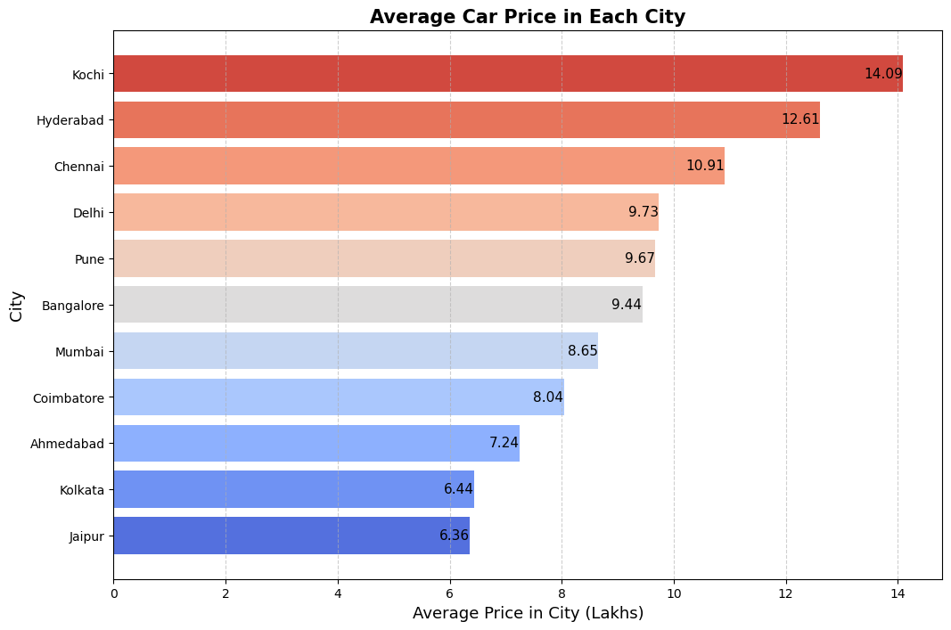

**Key Findings:**

* The city with the **highest average car price** is **Kochi (₹14.09 Lakh)**, followed by **Hyderabad (₹12.61 Lakh)** and **Chennai (₹10.91 Lakh)**.
* The **lowest average car prices** are in **Jaipur (₹6.36 Lakh)** and **Kolkata (₹6.44 Lakh)**.
* **Metropolitan cities like Delhi, Pune, and Bangalore** have moderately high average car prices (~₹9-10 Lakh).
* **Ahmedabad, Kolkata, and Jaipur** have the lowest average car prices, suggesting affordability in these markets.

**Inference:**

* Higher prices in **Kochi and Hyderabad** could be due to demand, taxation policies, or economic factors.
* Lower prices in **Jaipur and Kolkata** may indicate a price-sensitive market or fewer luxury car buyers.

**3. Vehicle Sales in Different Cities**

**Key Findings:**

* Mumbai records the highest vehicle sales (949 units), followed by Hyderabad (876 units).
* Ahmedabad has the lowest sales (275 units), indicating low vehicle demand.
* Coimbatore and Kochi have identical sales figures (772 units).
* Pune, Delhi, and Kolkata have moderate sales figures (~600-700 units).
* Bangalore and Jaipur report lower sales (~400-500 units).

**Inference:**

* **Mumbai and Hyderabad are strong markets**, possibly due to high population density and economic prosperity.
* **Ahmedabad and Bangalore show weak sales**, requiring market research to understand low demand.

**4. Vehicle Sales Distribution (Pie Chart Analysis)**

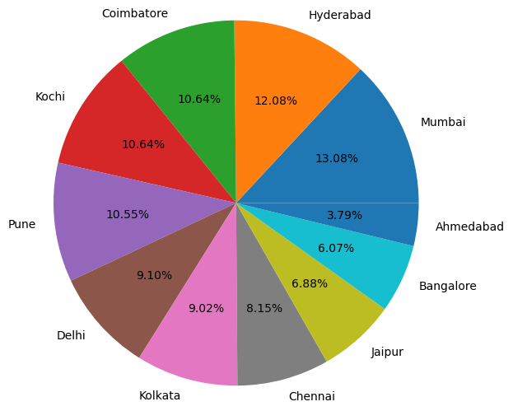

**Key Findings:**

* Mumbai holds the largest market share (~13.08%).
* Ahmedabad contributes the least (~3.79%) to overall vehicle sales.
* Hyderabad, Kochi, and Coimbatore contribute significantly (~10-12%).
* Bangalore and Jaipur have small shares (~6-7%).

**Inference:**

* **Mumbai dominates the market**, indicating strong purchasing power.
* **Ahmedabad’s low** share suggests a market with either fewer buyers or different mobility preferences.

**5. Correlation Between Car Prices and Sales**

**Key Observations:**

* **Higher car prices do not always mean lower sales** (e.g., **Kochi** has high prices but strong sales).
* **Cities like Ahmedabad and Bangalore** struggle with sales despite competitive prices.
* **Mumbai dominates** in both **price** and **sales**, indicating a strong market for all car segments.

**6. Price Distribution by Fuel Type**

**Observations**

1. **Price Distribution:**
   * The majority of vehicles are priced within the lower range (0-25 lakhs), with a steep decline in the number of vehicles as the price increases.
   * The distribution follows a right-skewed pattern, indicating that most vehicles are affordable, while only a few are priced at the higher end.
2. **Fuel Type Comparison:**
   * **Petrol** and **Diesel** vehicles dominate the dataset, contributing significantly to the price distribution.
   * **CNG** vehicles show a smaller distribution, indicating limited availability or adoption.
   * **LPG** and **Electric** vehicles appear to have a minimal presence in the dataset, possibly due to lower market penetration.
   * **Electric vehicles** exhibit a wider price range, with a few models extending beyond 100 lakhs, highlighting the presence of premium-priced EVs.
3. **Density Trends:**
   * The kernel density estimation (KDE) lines suggest that petrol and diesel cars have similar price distributions, with peaks around lower price ranges.
   * The price distribution for electric vehicles is spread out more, reflecting diverse pricing across budget and luxury segments.

**7. Conclusion & Business Recommendations**

**Conclusion:**

* **Mumbai and Hyderabad** are the **most lucrative markets** for car sales.
* **Kochi and Coimbatore have high demand** despite expensive cars.
* **Ahmedabad and Bangalore need a market boost** to increase vehicle adoption.
* **Kolkata and Jaipur are price-sensitive markets**, requiring affordable car models.
* **The automobile market is still dominated by petrol and diesel vehicles** in terms of availability and affordability.
* **CNG and LPG vehicles have limited presence**, indicating niche adoption.
* **Electric vehicles, while growing, are positioned at both ends of the price spectrum**, from affordable to luxury models.

**Business Recommendations:**

1. **Target Mumbai, Hyderabad, and Kochi** for premium and luxury car segments.
2. **Focus on affordability in Kolkata and Jaipur** by introducing budget-friendly models.
3. **Conduct market research in Ahmedabad and Bangalore** to understand weak demand.
4. **Improve financing options in mid-tier cities** like Pune and Coimbatore to encourage sales.
5. Further analysis could be conducted to explore price trends over time, market demand shifts, and the impact of government policies on fuel type preferences.
6. A deeper dive into brand-wise price segmentation could provide insights into pricing strategies.
7. Studying consumer preferences and vehicle sales data could help understand future trends in fuel type adoption.